**PART-I**

**User Creation**

**STEP 1:**

First Login to the URL (<http://tathyasathi.bangla.gov.in/configure/login.do>) with the credentials as required.

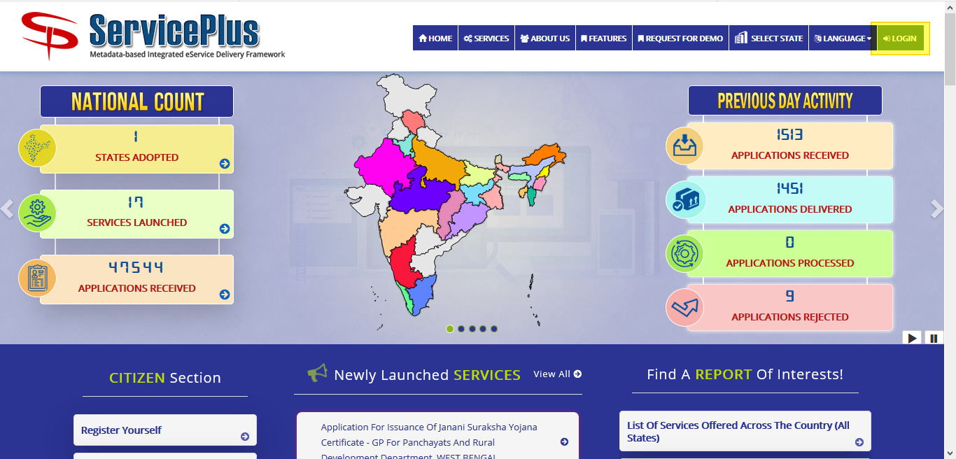

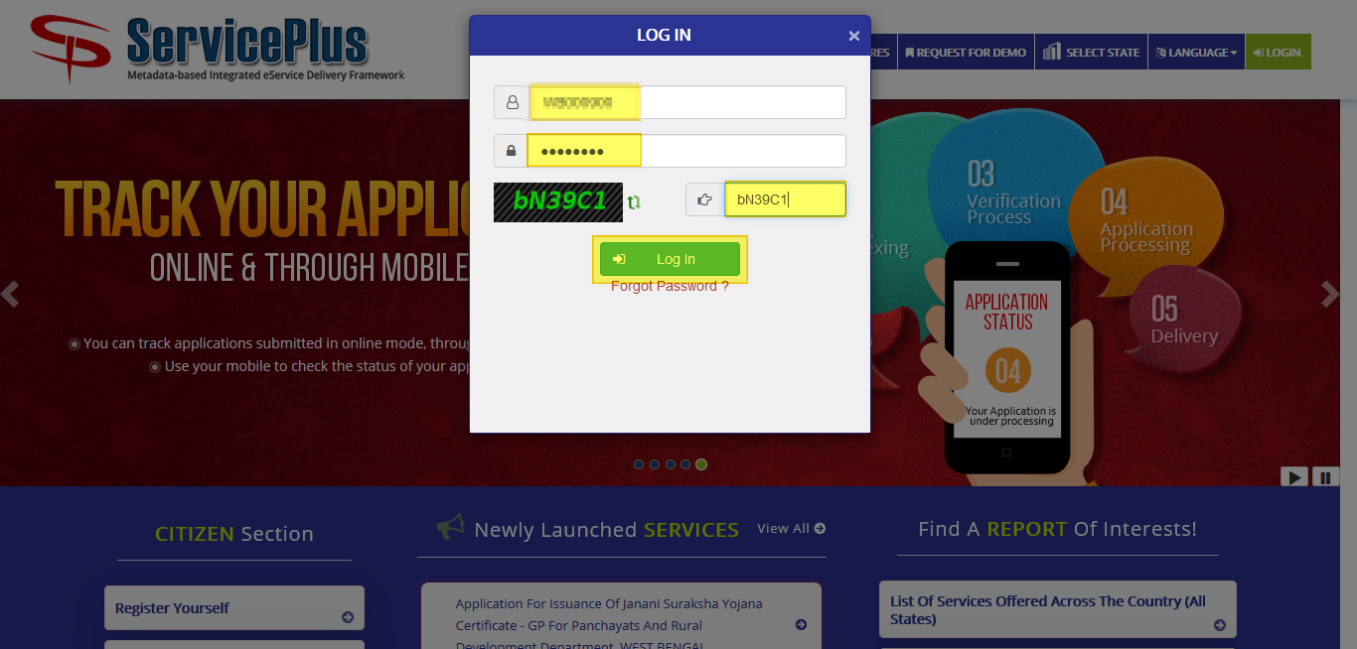

**STEP 2:**

Now fill in the form with the details.

Full Name should be like **Divisional manager -WBSEDCL -Berhampore.**

Select Designation **Divisional Manager**.

Email Id should be like **ta**********@gmail.com** and Login Preference should be selected to **System Generated** and Submit.

This would lead to the activation link which would be received in the email given so it would be corrected and activated.

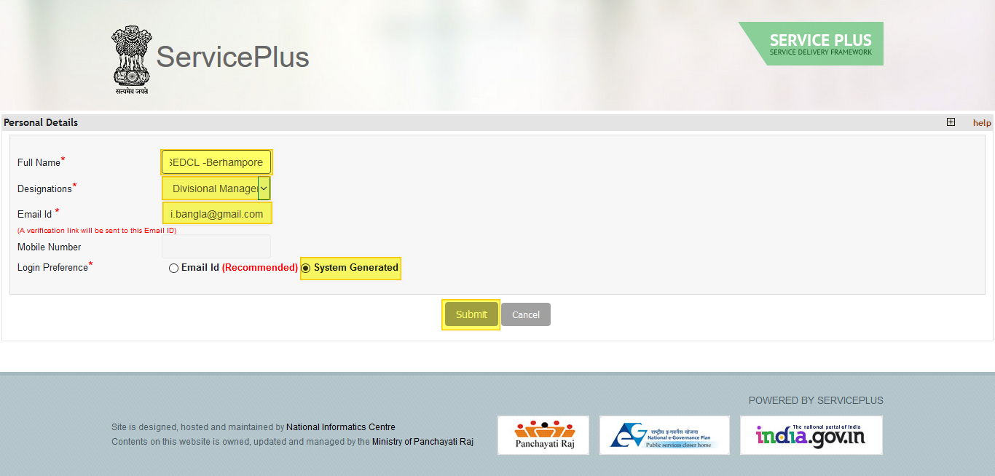

**STEP 3:**

A verification link is sent on your Email ID given by you e.g.: **ta********@gmail.com**. Please confirm your Email ID by clicking on the link and Reset Password.

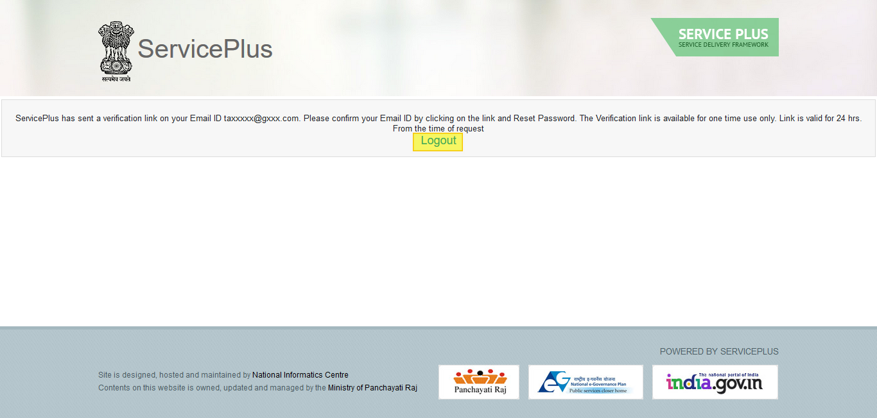

**STEP 4:**

Open your email and click on the activation link and reset the password.

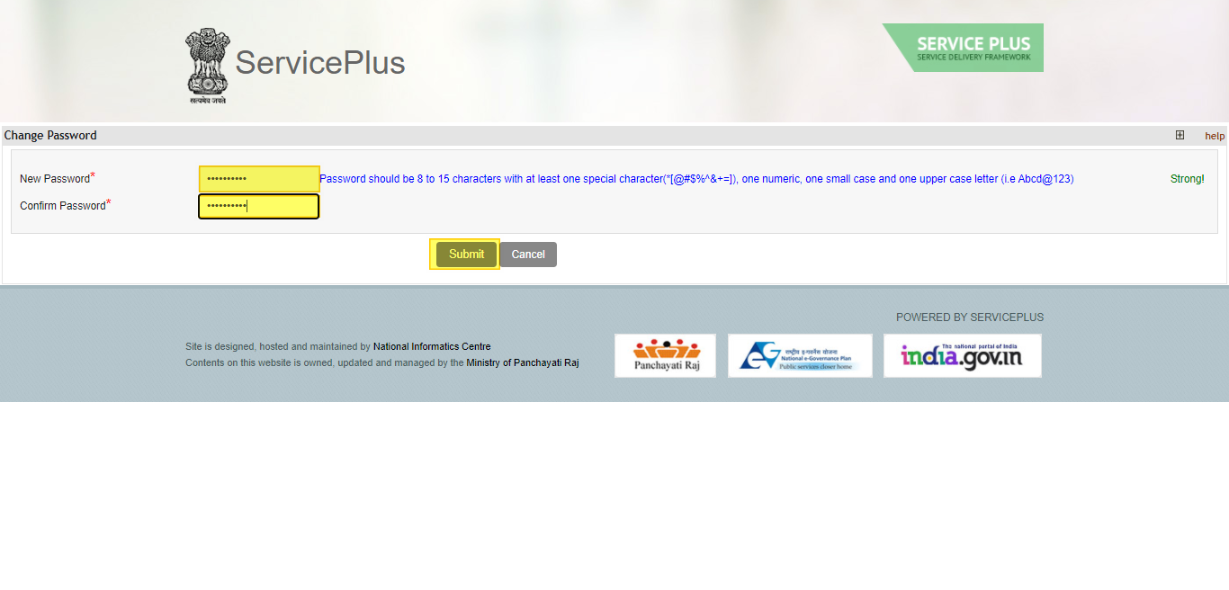

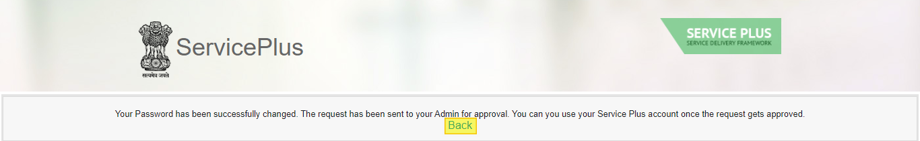 **Now the request have been sent to your Admin for approval**.

**PART -II**

**APPROVAL BY ADMIN**

**STEP 1:**

Login as a department Admin in service plus.





**STEP 2:**

Select **User Management** and click on **Manage User(s).**

Select **what do you want to do?** To **Add Employee to Office.**

And **Select Users** to **Unapproved Users.**

Click on **Get List** Button**.**

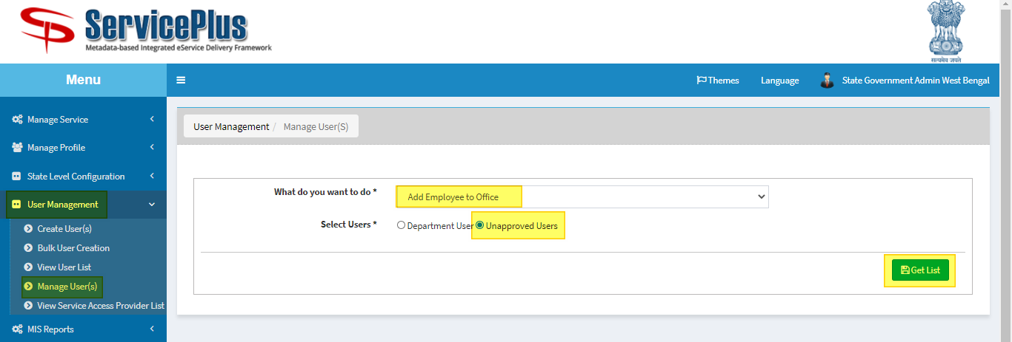

**STEP 3:**

Now Select the User and click on **Approve Users**.

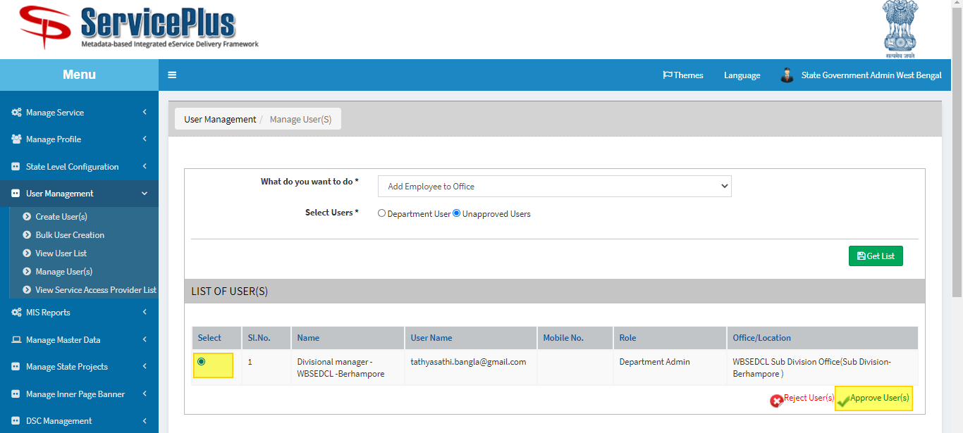

**STEP 4:**

Select the Designation **Divisional Manager** and **Role as** to **Department Admin** and submit**.**

